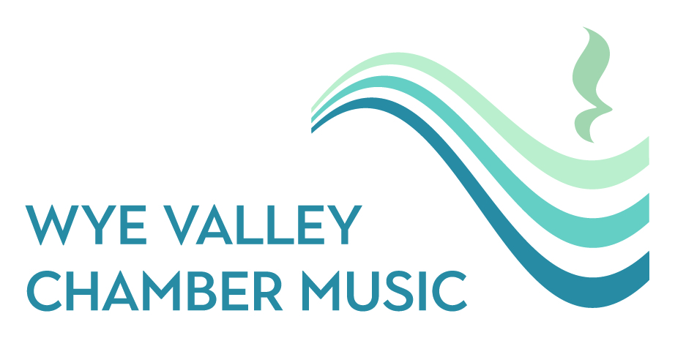

LEGACY PLEDGE FORM
WYE VALLEY CHAMBER MUSIC
Thank you for considering a gift to Wye Valley Chamber Music in your will.
If you have included (or intend to include) us in your will, we would be very grateful if you would let us know. This form is not legally binding and does not restrict your freedom to amend your will at any time. It simply helps us thank you and plan for the future.

1. YOUR DETAILS
Full name: _______________________________________________
Address: ________________________________________________________________________________________________________
Postcode: ______________________
Telephone (optional): _________________________________Email:______________________________________

2. MY LEGACY GIFT
☐ I have already included Wye Valley Chamber Music in my will
☐ I intend to include Wye Valley Chamber Music in my will
☐ I am considering leaving a gift and would like more information
Type of gift (if known):
☐ Residuary gift (a percentage of my estate)
☐ Pecuniary gift (a fixed sum)
☐ Specific gift (e.g. shares, property, instrument, other asset)
☐ I prefer not to say
Estimated value or percentage (optional):
__________________________________________________________

3. USE OF MY GIFT
☐ I would like my gift to be used where the need is greatest (recommended)
☐ I would like my gift to support the following area:
__________________________________________________________
Please note: while we will always try to honour your wishes, in some circumstances it may be necessary to use the gift for related charitable purposes.

4. RECOGNITION
☐ I am happy to be acknowledged as a Legacy Donor in concert programmes and on the website
☐ I would prefer my gift to remain anonymous
☐ Please discuss recognition options with me

5. STAYING IN TOUCH
☐ I am happy to receive occasional updates about the impact of legacy gifts
☐ I would prefer not to receive legacy-related communications
You can change your communication preferences at any time.

6. DATA PROTECTION
Wye Valley Chamber Music will process your personal data in accordance with UK data protection legislation (including the UK GDPR). We will only use your information to administer your pledge and communicate with you in line with your preferences.
Signature: ____________________________________________
Date: ________________________________________________

Please return this form to:
Victoria MacManus, Festival Manager, Wye Valley Chamber Music
Northridge House, Usk Road, Shirenewton, Monmouthshire, NP16 6RZ
info@wyevalleyfestival.com

Registered charity number: 1100171 Registered Company No: 04762005

